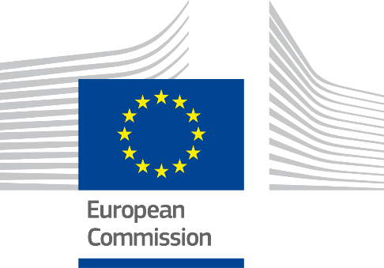



Digital Public Administration factsheet 2021

Iceland

***ISA2***

Table of Contents

1 Country Profile 4

2 Digital Public Administration Highlights 11

3 Digital Public Administration Political Communications 13

4 Digital Public Administration Legislation 20

5 Digital Public Administration Governance 24

6 Digital Public Administration Infrastructure 29

7 Cross-border Digital Public Administration Services 34

*Please note that the data collection exercise for the update of the 2021 edition of the Digital Public Administration factsheets took place between March and June 2021. Therefore, the information contained in this document reflects this specific timeframe*.



Country

Profile

1

# Country Profile

## Basic data

**Population**: 366 463 inhabitants (2020)

**GDP at market prices**: 19 022.2 (2020)

**GDP per inhabitant in PPS (Purchasing Power Standard EU 27=100)**: 125 (2020)

**GDP growth rate**: -6.6 (2020)

**Inflation rate**: 1.2 (2020)

**Unemployment rate**: 5.5 % (2020)

**General government gross debt (Percentage of GDP)**: No data available

**General government deficit/surplus (Percentage of GDP)**: No data available

**Area**: 103 000 km²

**Capital city**: Reykjavik

**Official EU language**: Icelandic

**Currency**: ISK

**Source**:[Eurostat](http://ec.europa.eu/eurostat/data/database) (last update: 26 June 2020)

## Digital Public Administration Indicators

The following graphs present data for the latest Generic Information Society Indicators for Iceland compared to the EU average. Statistical indicators in this section reflect those of [Eurostat](http://ec.europa.eu/eurostat/data/database) at the time the Edition is being prepared.

|  |  |
| --- | --- |
| Percentage of individuals using the internet for interacting with public authorities in Iceland | Percentage of individuals using the internet for obtaining information from public authorities in Iceland |
|  |  |
| Source: [Eurostat Information Society Indicators](http://appsso.eurostat.ec.europa.eu/nui/show.do?dataset=isoc_bde15ei&lang=en) | Source: [Eurostat Information Society Indicators](http://appsso.eurostat.ec.europa.eu/nui/submitViewTableAction.do) |
|  |  |
| Percentage of individuals using the internet for downloading official forms from public authorities in Iceland | Percentage of individuals using the internet for sending filled forms to public authorities in Iceland |
|  |  |
| Source: [Eurostat Information Society Indicators](http://appsso.eurostat.ec.europa.eu/nui/submitViewTableAction.do) | Source: [Eurostat Information Society Indicators](http://appsso.eurostat.ec.europa.eu/nui/submitViewTableAction.do) |

## Interoperability State of Play

In 2017, the European Commission published the [European Interoperability Framework](https://ec.europa.eu/isa2/sites/isa/files/eif_brochure_final.pdf) (EIF) to give specific guidance on how to set up interoperable digital public services through a set of 47 recommendations. The picture below represents the three pillars of the EIF around which the EIF Monitoring Mechanism was built to evaluate the level of implementation of the EIF within the Member States. It is based on a set of 71 Key Performance Indicators (KPIs) clustered within the three main pillars of the EIF (Principles, Layers and Conceptual model), outlined below.



Source: European Interoperability Framework Monitoring Mechanism 2020

For each of the three pillars, a different scoreboard was created to breakdown the results into their main thematic areas (i.e. the 12 principles of interoperability, the interoperability layers and the components of the conceptual model). The thematic areas are evaluated on a scale from one to four, where one means a lower level of implementation and 4 means a higher level of implementation. The graphs below show the result of the second EIF Monitoring Mechanism data collection exercise for Iceland in 2020.

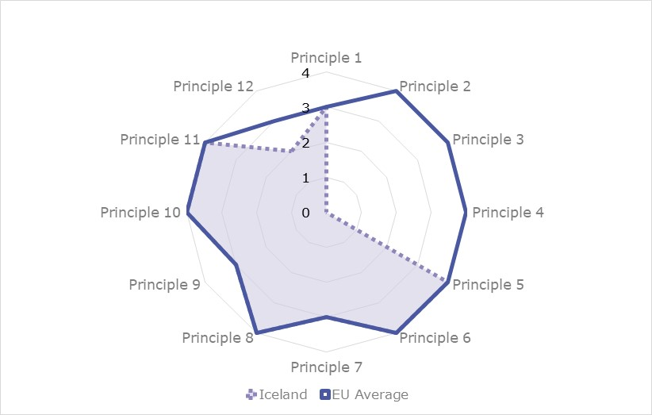

Source: European Interoperability Framework Monitoring Mechanism 2020

Iceland’s results in Scoreboard 1 show an overall good implementation of eight of the EIF Principles, despite the lack of data for Principle 2 (Openness), 3 (Transparency) and 4 (Reusability). Areas of improvements are concentrated in the Principles 1 (Subsidiarity and Proportionality), 7 (Inclusion and Accessibility) and 9 (Multilingualism) which show an upper-medium performance with the score of 3, and Principle 12 (Assessment of Effectiveness and Efficiency) which shows a lower-medium performance with the score of 2. Indeed, the alignment and tailoring of national interoperability frameworks and interoperability strategies with the EIF (Principle 1 – Recommendation 1), the use of e-accessibility specifications to ensure all public services are accessible to all citizens, including persons with disabilities, the elderly and other disadvantaged groups (Principle 7 – Recommendation 14), the availability of information systems and technical architectures that cater for multilingualism (Principle 9 – Recommendation 16) and the implementation of evaluation mechanisms to assess the effectiveness and efficiency of interoperable solutions (Principle 12 – Recommendation 19) are partial and could be bettered to reach the maximum score of 4.

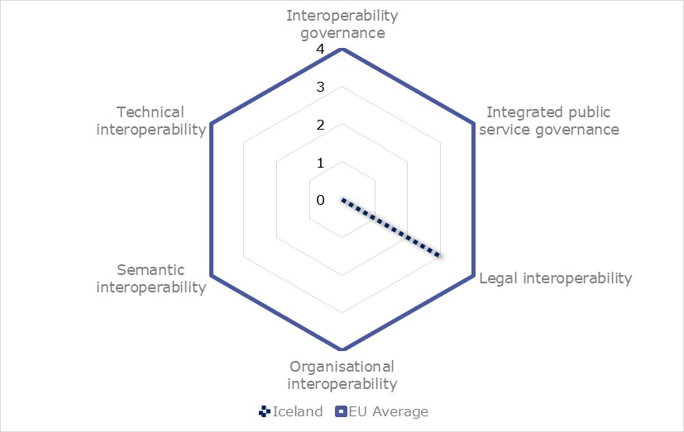

Source: European Interoperability Framework Monitoring Mechanism 2020

The Icelandic results for the implementation of interoperability layers assessed for Scoreboard 2 show lack of data for all but one of the interoperability layers, legal interoperability which shows an upper-middle performance with the score of 3. Legal interoperability could be enhanced in Iceland by focusing on the implementation of Recommendation 27, stating that legislation to establish a European public service must be consistent with relevant legislation, go under a ‘digital check’ and consider data protection requirements.

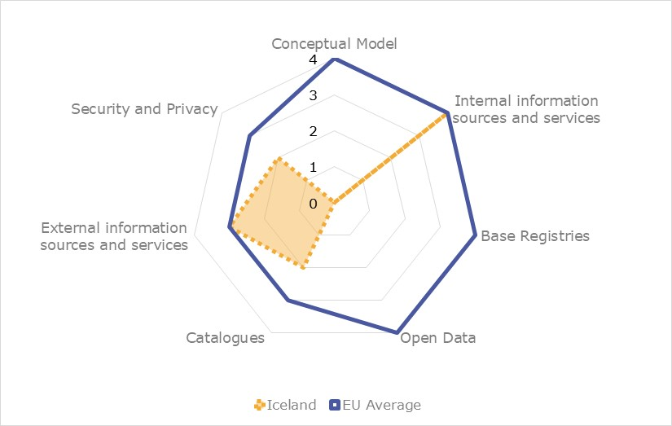

Source: European Interoperability Framework Monitoring Mechanism 2020

Iceland’s scores assessing the Conceptual Model in Scoreboard 3 are not available for the conceptual model itself, base registries and open data, however they show a good performance in the implementation of recommendations associated with internal information sources. Areas of improvement are concentrated in the implementation of recommendations related to catalogues, external information sources and services as well as security and privacy. Precisely, the lack of catalogues of public services, public data, and interoperability solutions put in place with common models describing them (Catalogues - Recommendation 44), the low use of external information sources and services while developing European public services (External information and services – Recommendation 45), the need to identify specific privacy requirements and measures for the provision of each public service and to use trust services according to the Regulation on eID and Trust Services (Security and Privacy – Recommendation 46 and 47) hinder the overall Icelandic scores for Scoreboard 3.

Additional information on Iceland’s results on the EIF Monitoring Mechanism is available online through [interactive dashboards](https://joinup.ec.europa.eu/collection/nifo-national-interoperability-framework-observatory/eif-monitoring).

## eGovernment State of Play

The graph below presents the main highlights of the latest eGovernment Benchmark Report, an assessment of eGovernment services in 36 countries: the 27 European Union Member States, as well as Iceland, Norway, Montenegro, the Republic of Serbia, Switzerland, Turkey, the United Kingdom, Albania and Macedonia (referred to as the EU27+).

The study evaluates online public services on four dimensions:

* User centricity: indicates the extent to which a service is provided online, its mobile friendliness and its usability (in terms of available online support and feedback mechanisms).
* Transparency: indicates the extent to which governments are transparent about (i) the process of service delivery, (ii) policy making and digital service design processes and (iii) the personal data processed in public services.
* Cross-border services: indicates the extent to which users of public services from another European country can use the online services.
* Key enablers: indicates the extent to which technical and organizational pre-conditions for eGovernment service provision are in place, such as electronic identification and authentic sources.

The 2021 report presents the biennial results, achieved over the past two years of measurement of all eight life events used to measure the above-mentioned key dimensions. More specifically, these life events are divided between six ‘Citizen life events’ (Career, Studying, Family life, measured in 2020, and Starting a small claim procedure, Moving, Owning a car, all measured in 2019) and two ‘Business life events’ (Business start-up, measured in 2020, and Regular business operations, measured in 2019).

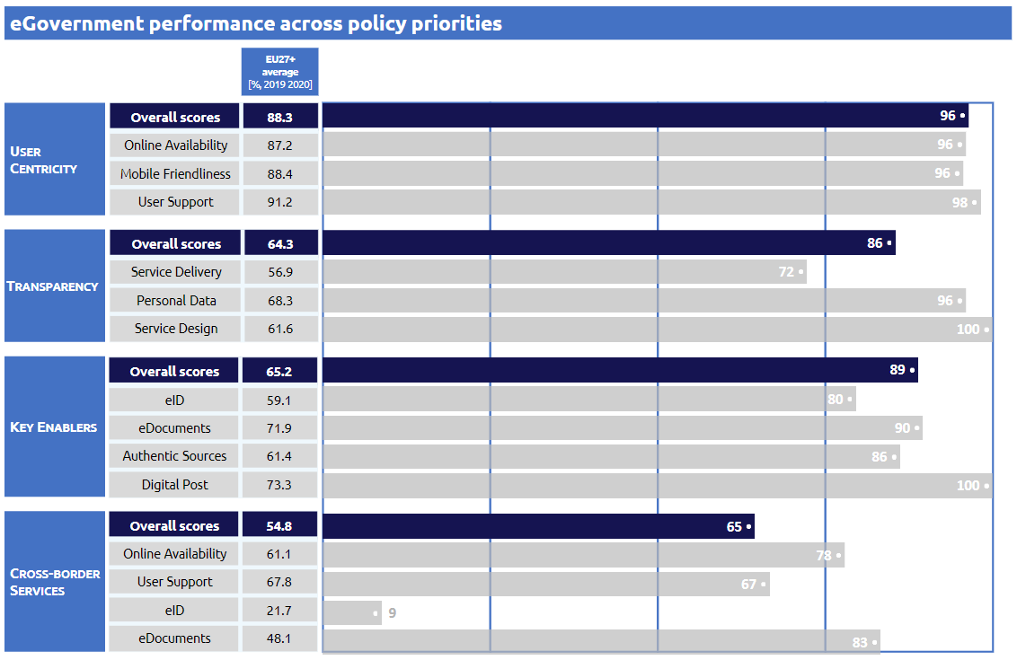

Source: [eGovernment Benchmark Report 2020 Country Factsheets](https://digital-strategy.ec.europa.eu/en/library/egovernment-benchmark-2021)



Digital Public Administration Highlights

2

# Digital Public Administration Highlights

Digital Public Administration Political Communications

In April 2021, the [new policy on sustainable public procurement](https://www.stjornarradid.is/efst-a-baugi/frettir/stok-frett/2021/04/15/Ny-innkaupastefna-Framsaekin-og-sjalfbaer-innkaup-laekka-kostnad-um-3-5-milljarda-a-ari/) was published and an [action plan](https://www.stjornarradid.is/gogn/rit-og-skyrslur/stakt-rit/2021/04/14/Sjalfbaer-innkaup-Adgerdaaaetlun-2021-2024/) for the years 2021-2024 has been approved. Both documents followed the publication of a [policy draft](https://samradsgatt.island.is/oll-mal/$Cases/Details/?id=2603) which emphasised the use of eProcurement and data in order to achieve cost-efficient and environmentally friendly procurement.

Iceland will continue to participate in [Digital North 2.0](https://www.stjornarradid.is/efst-a-baugi/frettir/stok-frett/2020/09/03/Rekstur-norraenna-fyrirtaekja-audveldadur-med-aukinni-samtengingu-stafraenna-kerfa/) cooperation, spearheaded by the Nordic Council of Ministers, that will enable greater moveability and ease of doing business across the Nordic and Baltic region. In March 2020 the ministries and delegations from the Nordic and Baltic countries participated in [committee meetings](https://www.stjornarradid.is/efst-a-baugi/frettir/stok-frett/2020/03/07/Aframhaldandi-samstarfi-Nordurlanda-og-Eystrasaltsrikja-um-stafraena-throun-/) to discuss the draft for the new cooperation plan.

[Digital policy was posted in the consultation portal](https://samradsgatt.island.is/oll-mal/$Cases/Details/?id=2968) and is expected to be announced early summer 2021.

Digital Public Administration Legislation

The [Digital Mailbox legislation process](https://www.stjornarradid.is/efst-a-baugi/frettir/stok-frett/2020/12/09/Skilvirkari-og-betri-opinber-thjonusta-med-stafraenu-postholfi-/) is ongoing to facilitate digitalisation of numerous processes that are currently bound by law to be on paper. Its development aims to improve the efficiency and delivery of public services and ensure a secure way of sharing data with individuals and legal entities, with communication occurring in a digital and central place.

The Draft [Digital Cloud Policy](https://www.stjornarradid.is/efst-a-baugi/frettir/stok-frett/2020/12/07/Stefna-um-notkun-skyjalausna-til-umsagnar-i-samradsgatt-/) was published for consultation in December 2020. The policy is expected to be published in 2021 and will establish the framework for the use of cloud solutions by public bodies.

The [National Architectural Security Guidelines](https://www.stjornarradid.is/efst-a-baugi/frettir/stok-frett/2020/10/27/Landsarkitektur-upplysingaoryggis-i-samradsgatt-/) were published for consultation in October of 2020. The guidelines aim to support and inform institutions on how to strengthen network security and coordinate working methods across the public sector.

Digital Public Administration Infrastructure

A significant investment was made as part of COVID-19 response in digital infrastructure and Ísland.is portal. For example driving licenses were made available in digital form in phone wallets, criminal record checks were digitized, API web design guide and central web services data catalogue was launched, revamped Ísland.is portal with life events was launched, open source design system went live to facilitate quick unified launch of digital applications and processes, most COVID-19 aid application processes were fully digital at launch in 2020 and the first connections to government data through the secure X-road data exchange layer were implemented.



Digital Public Administration Political Communications

3

# Digital Public Administration Political Communications

## Specific political communications on digital public administration

Digital Cloud Policy Draft 2020

In December 2020, the government published a draft of the Digital Cloud Policy in the government consultation portal. Consultation is ongoing and a policy is expected to be published in 2021. The [Digital Cloud Policy draft](https://samradsgatt.island.is/oll-mal/$Cases/Details/?id=2846) is the first comprehensive document on the use of cloud solutions by public bodies and is related to the government's goal of making Iceland one of the leading nations in the world in the provision of digital services.

The purpose of the public cloud policy is to achieve harmonised goals in the use of cloud solutions and their implementation. Cloud solutions are already in use by many public bodies and it is therefore urgent that work is done on coordinating these projects for efficiency and increased security.

The emphasis on digital services and user-centric service design have increased the demands on institutions for speed and efficient service. Cloud solutions that shorten the delivery time of infrastructure and IT services contribute to the quick, efficient and secure provision of digital services.

Cloud service also opens up new uses, e.g., in the field of artificial intelligence, and deeper data analysis, which would otherwise be difficult or impossible to exploit.

Policy and Action Plan 2021—2025

In 2018, all ICT affairs within the government were moved to the Ministry of Finance and Economic Affairs, although cybersecurity is managed by the Ministry of Transport and Local Government. A special taskforce was established under the name of Digital Iceland. The focus for 2018—2021 was:

* Increasing self-services through the national portal Island.is;
* Strengthening the IT infrastructure; and
* Increasing public agencies cooperation with the help of IT e.g. cloud solutions.

The Parliament announced the political strategy for digital efforts in the [fiscal plan for 2021—2025.](https://www.stjornarradid.is/library/01--Frettatengt---myndir-og-skrar/FJR/FJR_Fjarmalaaetlun_V5.pdf)

The focus of the coming semesters will be threefold:

* Urgent investments to reduce operational risk and meet the requirements for the basic services of institutions;
* Strengthening technological infrastructure that contributes to increased operational efficiency, increased safety, flexibility or capacity; and
* Definition of opportunities that contribute to increased development and utilisation of new technologies for improved service, increased security and efficiency. Such projects are related to e.g. strong co-operation with the Nordic and Baltic countries, in line with the Digital North declaration of cooperation. The EU also recently launched the Europe Fit for the Digital Age programme, which aims to systematically build digital infrastructure and facilitate the widespread deployment of digital technologies for government, citizens and businesses. Iceland fully participates in the programme.

A policy on public digital services was published in the consultation portal in April 2021. It outlines the government’s vision for the use of information technology and digital services to provide excellent services in a secure manner. It is also intended to strengthen Iceland's competitive position and increase prosperity through innovation and a more efficient society.

Digital Iceland

The technical policy of Digital Iceland was published in 2019. The policy sets a technical framework for all projects carried out under the leadership of both the Ministry of Local and Economic Affairs and the task force Digital Iceland, in cooperation with all agencies, municipalities, ministries and enterprises. The strategy is an important part of the government's plan on improved digital communication to the public. It also supports the objectives defined in the Nordic/Baltic Partnership, as stated in the Digital North Declaration.

To ensure progress, in the wide range of public digital projects planned, Digital Iceland published a tender in December 2019. In the tender, Digital Iceland requested to enter an agreement with up to eighteen teams to work on digital public solutions for the national portal [Island.is](https://island.is/).

A revamped portal for public services, [Island.is](https://island.is/), was launched in 2020 and it aims to be the central point of access for most digital public processes.

Digital North

The ministerial declaration [Digital North](https://www.norden.org/en/declaration/nordic-baltic-region-digital-frontrunner) was signed in 2017 by the Ministers for Digital Development of Norway, Sweden, Denmark, Finland, Iceland, Faroe Islands, Greenland, Åland, Estonia, Latvia and Lithuania. The declaration supports the policy goal of making the Nordic-Baltic region a digital frontrunner by:

* Strengthening the digital transformation potential of governments and societies, especially by creating a common area for cross-border digital services in the public sector;
* Strengthening enterprises’ competitiveness through digitalisation; and
* Enhancing the digital single market in the Nordic-Baltic region.

The Digital North declaration aims to increase the collaboration among countries and to develop joint infrastructure projects, such as the 5G mobile technology and the use of artificial intelligence (AI).

In 2020, the [Ministerial Declaration Digital North 2.0](https://www.norden.org/en/declaration/ministerial-declaration-digital-north-20) for the years 2021–2024 was finalised. The text is in line with the [Vision 2030](https://www.norden.org/en/our-vision-2030) for the Nordic countries and presents three policy goals:

1. Increase mobility and integration in the Nordic and Baltic region by building a common area for cross-border digital services;
2. Promote green economic growth and sustainable development in the Nordic-Baltic region through data-driven innovation and a fair data economy for efficient sharing and re-use of data; and
3. Promote Nordic-Baltic leadership in the EU/EEA and globally in a sustainable and inclusive digital transformation of our societies.

These policy goals aim to address concrete societal issues and make the region the most digitally integrated in the world.

Iceland Rural Fibre Project

Around 369 000 people live in Iceland in 2021, 4.7% of which live in rural areas. The [Iceland Rural Fibre Project](https://www.government.is/news/article/2018/01/18/Fjarskipti-Island-ljostengt/) is a government initiative to roll out fibre to nearly all legal homes in rural areas from 2016 to 2021. The State contributes to the funding of the project, and local governments can apply for subsidies that depend on their own contributions. The project is overseen by the Telecommunications Fund. Fibre-rollout in rural areas also plays a role in upgrading core communications systems nationwide, which is a prerequisite for greater reliability, coverage, and data-transmission speed across all mobile networks for the whole country. The project will end successfully in 2021 and will contribute to the main broadband policy goal, namely that 99.9% of households and businesses nationwide have access to fibre connections by the end of 2025.

## Interoperability

Unique IT Supplier for the Entire Public Sector

On 1 June 2019, Iceland became the first country to sign a contract which will make Microsoft the sole IT supplier for its entire public sector. The country teamed up with a single IT partner for the provision of a common cloud platform: Microsoft 365.

The introduction of Microsoft 365 aims to consolidate all services into a single license, while guaranteeing increased communication and collaboration between institutions.

Peter Quarfordts Skov, Public Sector Director at Microsoft Denmark & Iceland, commented that the contract marked a shift in the way public sector and public services are perceived. He added that, as more countries digitalise their public services, there is an increasing need to enhance services, products and processes, not to mention the level of security. Even though the decision should lead to an increased interoperability among different public bodies, the risk of a vendor lock-in is higher.

National Interoperability Framework

National research on how to improve interoperability has indicated that interoperability can only be enhanced through comprehensive harmonisation and communication between systems, suggesting the need for new strategies and corresponding frameworks. Several parties, led by the Ministry of Finance and Economic Affairs, are involved in the establishment of a framework including all government levels, public institutions and private entities.

One part of the framework, namely the ‘[Coordination of the public entities arrangements regarding information security](https://www.stjornarradid.is/efst-a-baugi/frettir/stok-frett/2020/10/27/Landsarkitektur-upplysingaoryggis-i-samradsgatt-/)’, was put in a [general consultation process](https://samradsgatt.island.is/oll-mal/$Cases/Details/?id=2817) in the government's consultation portal in the second half of the 2020.

The [National Architecture on Information Security](https://samradsgatt.island.is/Skrar/$Cases/GetCaseFile/?id=%7bdec2a011-8417-eb11-9b9b-005056bcce7e%7d) is intended to guide institutions on how they can strengthen network security and harmonize working methods across the public sector. It is one of the eight chapters in the technical architecture of public entities:

1. Architecture is managed at the appropriate level based on a common framework
2. Architecture promotes harmonization, innovation and efficiency
3. Architecture and legal environment support each other
4. Security, privacy and confidentiality are guaranteed
5. Processes between public bodies are efficient and automatic
6. Data is shared between public bodies and reused
7. IT solutions and systems work seamlessly together
8. Data is delivered and services are provided reliably

The National Architecture on Information Security is therefore a more detailed definition of the fourth chapter in the technology architecture. Work on other chapters is ongoing and they will be published as the work progresses and will thus form one whole.

As reported in chapter 6.3, Iceland has adapted the X-Road data exchange layer which is based on API structure. The aim is to connect all IT systems that need to exchange data to increase interoperability between government agencies.

## Key enablers

### Access to public information

No political communication has been adopted in this field to date.

### eID and Trust Services

NOBID

Iceland is a member of the [Nordic-Baltic cooperation project (NOBID)](https://www.digdir.no/om-oss/nordic-baltic-eid-project-nobid/1342) on supporting the implementation and use of the national eID infrastructure. The stated goal of the NOBID project is to offer citizens and businesses borderless access to digital services throughout the Nordic-Baltic region using their own national eIDs. The project aims to identify both technical and legal barriers and set the requirements for enabling interoperability both nationally and in a Nordic and Baltic context.

### Security aspects

National Cybersecurity Strategy 2015-2033

The first [Icelandic Cybersecurity Strategy](https://www.stjornarradid.is/media/innanrikisraduneyti-media/media/frettir-2015/Icelandic_National_Cyber_Security_Summary_loka.pdf) was presented to the government and Parliament in 2015 by the Minister for the Interior. The strategy was meant to cover the period 2015—2026. The strategy established the Cyber Security Council, which was assigned a key role in implementing the strategy and its action plan. It is composed of representatives from ministries and authorities in charge of cyber-related issues. It has proven to be a very useful platform for information exchange and coordination. Furthermore, the strategy established the Cyber Security Forum, a platform for cooperation between the public and private sectors.

In June 2019, the Parliament of Iceland agreed on a parliamentary resolution put forward by the government containing new strategies for cyber security, as well as for communication, postal services and Registers Iceland. The resolution was prepared by the Minister for Transport and Local Government, who is responsible for cyber security within the government. This [new cybersecurity strategy](https://www.althingi.is/altext/149/s/1688.html) is valid for the years 2019—2033 and therefore replaces the previous one. The Parliament also approved a corresponding resolution containing an [action plan](https://www.althingi.is/altext/149/s/0544.html) for the same time period. The new strategy pursues similar goals to the previous one, but it has more political weight as it was put forward by the government and approved by Parliament.

A secure cyber space is considered one of the main cornerstones for economic prosperity in Iceland. Iceland shall be prepared to detect and respond to cyber threats, tackle cybercrime, attacks, espionage and the abuse of personal and commercial data.

The new action plan focuses on:

1. Capacity building, with improved analytical and response capabilities, based on risk management and resilience;
2. Cyber security by default, covering purchases as well as development;
3. Cyber security awareness, to be improved by general and targeted campaigns, events and competitions;
4. Education and research, covering both domestic and international activities and cooperation;
5. Cooperation and coordination between ministries, authorities and with the private sector;
6. International commitments and cooperation, including ensuring a proper legal framework and addressing security issues; and
7. Assessment of progress based on the evaluation report from the Oxford University and on other external evaluations such as those by the ITU and the NCSI.

### Interconnection of base registries

No political communication has been adopted in this field to date.

### eProcurement

Public Procurement - Ranking and Options

In February 2020, a status report on public procurement and [a policy draft](https://samradsgatt.island.is/oll-mal/$Cases/Details/?id=2603) were posted on the government consultation portal. The policy draft emphasised the use of eProcurement and data for sound and sustainable procurement. The policy draft also stressed the need to increase the use of digital sourcing and information technology for data analysis and joint purchasing.

The new [policy on sustainable public procurement](https://www.stjornarradid.is/efst-a-baugi/frettir/stok-frett/2021/04/15/Ny-innkaupastefna-Framsaekin-og-sjalfbaer-innkaup-laekka-kostnad-um-3-5-milljarda-a-ari/) was published in April 2021. A three-year [action plan](https://www.stjornarradid.is/gogn/rit-og-skyrslur/stakt-rit/2021/04/14/Sjalfbaer-innkaup-Adgerdaaaetlun-2021-2024/) for the years 2021—2024 emphasised the use of digital procurement, systems, data and accessibility for SMEs.

## Domain-specific political communications

No political communication has been adopted in this field to date.

## Emerging Technologies

Status Report on AI

In February 2019, a committee appointed by the Prime Minister delivered a [status report](https://www.stjornarradid.is/lisalib/getfile.aspx?itemid=03be6340-3bfc-11e9-9436-005056bc4d74) and suggested an action plan for the government concerning the fourth industrial revolution. The report concluded that Iceland is well placed to deal with the development and use of artificial intelligence due to the following elements:

* Citizens have high trust in public bodies and businesses operating in public services;
* Public bodies and businesses are technically advanced and IT based;
* The public sector possesses technological infrastructures and has been collecting data for several decades;
* Institutions have based their activities on IT and access to knowledge; and
* Good cooperation between employers’ associations, labour unions and the government facilitates the reorganisation of the labour market, adapting it to the changes brought about by the fourth industrial revolution.

The status report pointed out that, as the Icelandic community is characterised by trust and respect for fundamental values such as human rights and privacy, it is necessary for the government to develop an artificial intelligence policy which preserves the rights and freedoms of the individuals.

The government should focus on the following guiding principles:

* The development of artificial intelligence should respect the society’s moral values as well as human rights and democracy;
* The development and use of artificial intelligence should guarantee the integrity and fairness of communication and decision-making processes;
* Artificial intelligence research, development and use should promote and ensure responsible and trusted solutions. The inspectors should assure that artificial intelligence is operated in accordance with the principles of responsibility and trustworthiness; and
* Security should be guaranteed throughout the development, operation and control of systems that use artificial intelligence.

In the 2022 budget plan, the government announced an Icelandic version of an AI course to be accessible free of charge for everyone, based on the [AI course](https://www.elementsofai.is/) developed by the University of Helsinki.

Policy on AI

A strategy for AI, which aims to maximize social and economic recovery and minimize costs and risks, is currently [being developed](https://samradsgatt.island.is/oll-mal/$Cases/Details/?id=2933) within the Prime Minister's Office. Katrín Jakobsdóttir, Prime Minister, has appointed a committee to submit proposals for a clear vision for the future on how the Icelandic society can work with AI for the benefit of all. The committee is intended to answer the following questions:

* What are the rights of Icelanders towards new technology?
* What should be the role of AI technology in Icelandic society?
* What value should Icelandic society have in mind when introducing new technology? and
* At what level will Iceland discuss and resolve issues that arise regarding the implementation or use of new technology?

The project is part of an action plan for Iceland in the fourth industrial revolution, and the committee consists of individuals with diverse backgrounds and expertise, including ethics, technology, the labour market and societal changes due to new technology. The policy should lay the foundation for individuals and companies to be able to use and develop technology in social harmony.



Digital Public Administration Legislation

4

# Digital Public Administration Legislation

## Specific legislation on digital public administration

Digital Mailbox Act

In 2020, an [Act on Digital Mailbox](https://www.stjornarradid.is/efst-a-baugi/frettir/stok-frett/2020/12/09/Skilvirkari-og-betri-opinber-thjonusta-med-stafraenu-postholfi-/) on the national portal was drafted. The purpose of the act is to promote efficient public service, increase transparency in the handling of cases and increase efficiency in the administration. At the same time, the aim is for the government’s main means of communication with individuals and legal entities to be digital and accessible in one single place.

The Digital Mailbox Act is a very important step to ensure that public entities have the adequate legal authority to send data to individuals and legal entities, digitally, so that the publication of documents has the same legal effect as when it is sent in other ways.

The act is yet to be formally adopted by Parliament, but it has already been approved in the first reading.

Information Act

The [Information Act](https://www.althingi.is/lagas/nuna/2012140.html) was approved by the Parliament at the end of 2012 and came into force on 1 January 2013. Its objective is to guarantee transparency in government administration and in the handling of public interests, inter alia with the purpose of strengthening the following aspects:

* Right to information and freedom of expression;
* Public participation in a democratic society;
* Checks and balances provided by the media and the public on government authorities;
* Media communication on public affairs; and
* Public trust in government administration.

This act applies to all government activities and private entities owned by the State (51% of shares or more).

After the adoption of Act No. 140/2012, the [Information Act](http://www.althingi.is/lagas/141b/2012140.html) (No. 50/1996) only applied to municipalities with fewer than 1 000 citizens until 1 January 2016.

Administrative Procedures Act

On 10 March 2003, the [Administrative Procedures Act](https://www.government.is/publications/legislation/lex/?newsid=fe364017-fd27-11e7-9423-005056bc4d74) (No. 37/1993) was amended, adding a special chapter on the electronic activities performed by the Public Administration. Through this amendment, general obstacles to the development of electronic administration were removed. While formulating the amendment, the responsible committee was guided by the concept of equivalent value, and also emphasised the need to maintain technical neutrality. The changes included permission – and not obligation - for the electronic handling of governmental administration cases.

## Interoperability

No legislation has been adopted in this field to date.

## Key enablers

### Access to public information

Reuse of Public Sector Information

Conditions on the reuse of public sector information are partly covered by the [Information Act](http://www.althingi.is/lagas/141b/2012140.html). The act defines public access to information and the restrictions on the right to information. With respect to the European Directive on the reuse of public sector information ([PSI Directive](http://eur-lex.europa.eu/LexUriServ/LexUriServ.do?uri=OJ:L:2003:345:0090:0096:en:PDF), 2003/98/EC), the act includes almost all items with the exception of access and reuse of information through electronic means such as databases.

The [Act on the reuse of public information](https://www.althingi.is/lagas/151b/2018045.html) entered into force on 26 May 2018. Its main object is to ensure harmonised minimum rules on the permitted re-use of the information to which the public has a right of access and to increase the reuse of public information for the benefit of society as a whole. The act applies to the state, municipalities, their institutions and other public bodies as well as associations that these parties, one or more, have with them. The act states that a public body is obliged to comply with a request for permission to re-use existing information in the custody of a public body to which the public has a right of access on the basis of the Information Act or other laws. The right to reuse public information does not apply to:

1. Information compiled by public bodies for commercial purposes,
2. Statistical data applicable to confidentiality,
3. Data, files and information from databases over which a third party has legally protected rights under the Copyright Act.

The right is, however, present when the state, municipalities or their institutions have one such right over information, provided that a public body that represents the rights does not fall under the fourth paragraph.

This Act implements Directive 2013/37 / EU of the European Parliament and of the Council of 26 June 2013, which was incorporated into Annex XI. Annex to the EEA Agreement by Decision of the EEA Joint Committee no. 59/2017, amending Directive 2003/98 / EC of 17 November 2003 on the re-use of public information, which was incorporated into Annex XI. Annex to the EEA Agreement by Decision of the EEA Joint Committee no. 105/2005.

### eID and Trust Services

Transposition of the eIDAS Regulation

The [eIDAS Regulation](https://eur-lex.europa.eu/legal-content/EN/TXT/?uri=uriserv%3AOJ.L_.2014.257.01.0073.01.ENG) (2014/910/EU) is a European legal act setting the rules for a secure and seamless use of electronic identification and electronic transactions in the European Single Market. The eIDAS Regulation has been transposed into Icelandic law with the Act on Electronic Identification and Trust Services for Electronic Transactions ([No. 55/2019](https://www.althingi.is/lagas/nuna/2019055.html)) and associated regulations ([No. 100/2020](https://www.reglugerd.is/reglugerdir/eftir-raduneytum/efnahags--og-vidskiptaraduneyti/nr/21816) and [No. 310/2020](https://www.reglugerd.is/reglugerdir/eftir-raduneytum/atvinnuvega--og-nyskopunarraduneyti/nr/21892)).

Supporting legislation can be found in the [Electronic Commerce Act](https://www.stjornarradid.is/media/atvinnuvegaraduneyti-media/media/Acrobat/Act-No-30-2002-on-Electronic-Commerce-and-other-Electronic-Services.pdf) from 2002, the [Administrative Procedures Act](https://www.althingi.is/lagas/150a/1993037.html), as amended in 2003, and the [Public Procurement Act](https://www.althingi.is/lagas/nuna/2016120.html), as amended in 2019.

### Security aspects

Data Protection Act

The [Act on Data Protection and the Processing of Personal Data](https://www.personuvernd.is/media/uncategorized/Act_No_90_2018_on_Data_Protection_and_the_Processing_of_Personal_Data.pdf) (No. 90/2018) has transposed into national law the General Data Protection Regulation (2016/679/EU). The act is enforced by the [Data Protection Authority](https://www.personuvernd.is/information-in-english/), which is responsible for the supervision of all processing operations covered by the Act on Data Protection and the Processing of Personal Data.

NIS Directive

In June 2019, the Icelandic Parliament adopted [Act No. 78/2019](https://www.althingi.is/lagas/nuna/2019078.html), regarding cyber security, based on the NIS model. The act, which redefined Iceland’s cyber security strategy, was approved in 2015 and entered into force on 1 September 2020. The act also defined the legal framework which the Cyber Security Council shall act within in order to implement the new strategy and action plan.

### Interconnection of base registries

No political communication has been adopted in this field to date.

### eProcurement

Public Procurement Act

The [Public Procurement Act](https://www.stjornarradid.is/lisalib/getfile.aspx?itemid=ec4a126d-8818-11e7-9419-005056bc4d74) (No. 120/2016) and subsequent regulations replaced an older act (No. 84/2007) and transposed three EU Directives ([2014/25/EU](https://eur-lex.europa.eu/legal-content/EN/TXT/?uri=CELEX%3A32014L0025), [2014/24/EU](https://eur-lex.europa.eu/legal-content/EN/TXT/?uri=celex%3A32014L0024) and [2014/23/EU](https://eur-lex.europa.eu/legal-content/en/TXT/?uri=CELEX:32014L0023)). All relevant provisions for eProcurement have been implemented, such as eNotice, eAccess, eSubmission, eEvaluation and eAward. A provision for [trusted electronic signatures](https://www.althingi.is/altext/stjt/2019.055.html#G10) was added to the act in 2019, as well as a provision for eInvoice acceptance by all government agencies based on the new standard [EN 16931](https://www.reglugerd.is/reglugerdir/allar/nr/044-2019).

## Domain-specific legislation

Act on Electronic Commerce and Other Electronic Services

The [Act on Electronic Commerce and Other Electronic Services](https://www.atvinnuvegaraduneyti.is/media/Acrobat/Act-No-30-2002-on-Electronic-Commerce-and-other-Electronic-Services.pdf) (No. 30/2002) states that electronic contracts are equivalent to written contracts and that electronic services provided by a service provider established in Iceland shall conform to Icelandic law on the establishment and operation of the service. The act does not apply to electronic services relating to taxation. However, in this field, there are two main acts applying to electronic commerce: the [Income Tax Act](https://www.government.is/media/fjarmalaraduneyti-media/media/Act_no_90_2003_01022012.pdf) (No. 90/2003) and the [Value Added Tax Act](https://www.government.is/media/fjarmalaraduneyti-media/media/skjal/Regulation_No_470_1991.pdf) (No. 50/1988). According to the former, a legal entity is taxable in Iceland if it is domiciled in this country. The latter introduced several special provisions concerning imports.

eInvoicing

In January 2019, the national [Regulation 44/2019](https://www.reglugerd.is/reglugerdir/eftir-raduneytum/fjarmala--og-efnahagsraduneyti/nr/21393) stipulated that all public entities shall accept eInvoices according to the standard EN 16931 for contracts covered by the Act on Public Procurement. Furthermore, the Ministry of Finance and Economic Affairs has declared that governmental agencies only accept elnvoices since 1 January 2020. As of April 2020, the government also issues all invoices as eInvoices.

## Emerging technologies

No legislation has been adopted in this field to date.



Digital Public Administration Governance

5

# Digital Public Administration Governance

## National

### Policy

Ministry of Finance and Economic Affairs

The [Ministry of Finance and Economic Affairs](https://www.government.is/ministries/ministry-of-finance-and-economic-affairs/) is responsible for the formulation of the policy on digital transformation. There is an extensive collaboration and consultation with other governmental bodies and actors.

In 2017, all ICT affairs within the government were transferred to the Ministry of Finance and Economic Affairs, although cyber security is governed by the Ministry of Transport and Local Government. In 2018, the Ministry of Finance and Economic affairs established a special taskforce, Digital Iceland, for the coordination and execution of core projects.

|  |  |
| --- | --- |
|  | **Bjarni Benediktsson**  **Minister for Finance and Economic Affairs**  **Contact details:**  **Ministry of Finance and Economic Affairs**  Arnarhvoli við Lindargötu  101 Reykjavik  **Tel.:** +354 545 9200  E-mail: fjr@fjr.is  **Source:**<https://www.government.is/ministries/ministry-of-finance-and-economic-affairs/> |

The primary role of the Ministry of Finance and Economic Affairs is to manage public finances and economic affairs. The ministry is responsible for financial market issues, improving corporate governance and planning. It actively manages the State's human resources and takes the lead in improvements and innovation in central government operations. The minister directs all operations and is responsible for all the ministry's administrative decisions.

The Ministry of Finance and Economic Affairs includes five departments: the Minister's Secretariat, the Department of Economic Affairs and Financial Services, the Department of Fiscal Affairs, the Department of Taxation and the Department of Public Management and Reform. The IT affairs are under the Department of Public Management and Reform.

Two other departments, the Legal and the Administrative Departments, operate on an interdepartmental basis. A special section, the Employment and Human Resources, is responsible for the State's human resources on behalf of the Minister.

In 2020, the Ministry worked on drafting a new digital policy for Iceland. The [strategy](https://island.is/s/stafraent-island/stafraen-stefna) was published in mid-2021.

Ministry of Industries and Innovation

The [Ministry of Industries and Innovation](https://www.government.is/ministries/ministry-of-industries-and-innovation/) covers all sectors of ordinary business and economic activity. The ministry’s main goal is to pave the way for a vigorous and forward-looking economy. The ministry is responsible for all electronic business relations and therefore also for eIDAS incorporation.

Ministry of Transport and Local Government

The [Ministry of Transport and Local Government](https://www.government.is/ministries/ministry-of-transport-and-local-government/) is responsible for telecommunications, digital communication, internet security and postal services, as well as local government administration, regional policy, citizens’ registration and property and real estate valuation.

### Coordination

Digital Iceland – A taskforce under the Ministry of Finance and Economic Affairs

The [Digital Iceland](https://island.is/stafraent-island) taskforce is a special unit within the ministry that coordinates digital matters in the public sector.

### Implementation

Digital Iceland – A taskforce under the Ministry of Finance and Economic Affairs

The [Digital Iceland](https://island.is/stafraent-island) taskforce is a special unit within the ministry that manages the implementation of digital projects with the aim of providing citizens with better digital services.

### Support

Digital Iceland – A taskforce under the Ministry of Finance and Economic Affairs

The [Digital Iceland](https://island.is/stafraent-island) taskforce is a special unit within the ministry that provides support to public entities regarding digital matters and the implementation of digital projects with the aim of providing citizens with better digital services.

### Interoperability coordination

Ministry of Finance and Economic Affairs

The main body responsible for interoperability activities in Iceland is the [Ministry of Finance and Economic Affairs](https://www.government.is/ministries/ministry-of-finance-and-economic-affairs/).

### Base registry coordination

Registers Iceland

[Registers Iceland](https://www.skra.is/) is the Icelandic State’s registry of base registries. More specifically, it gathers data on individuals and real estate. Registers Iceland records certain basic information on all persons who are or have been domiciled in Iceland and Icelandic citizens residing abroad, as well as changes in their status. The Real Estate Register contains all the basic information on properties, land and waste, as well as structures that are on them. It includes real estate and fire insurance assessments, the property surface area, and the property reference number. Registers Iceland gathers information through citizens’ and public bodies’ notification.

### Audit

National Audit Office

The [National Audit Office](https://rikisendurskodun.is/en/) is mandated by the Parliament to oversee the State finances, its institutions and State enterprises. The office monitors the State’s revenues and verifies whether appropriations and assets are used and allocated in an efficient and proper manner, in accordance with the Parliament’s conditions and decisions.

### Data Protection

Icelandic Data Protection Authority

Pursuant to Chapter VI of Regulation (EU) 2016/679, the [Data Protection Authority (DPA)](https://www.personuvernd.is/information-in-english/) is a supervisory body which shall oversee the implementation of the Regulation, of Act No. 90/2018, and of special legal provisions concerning the processing of personal data and other related rules.

The Data Protection Authority is an independent body managed by a special Board of Directors. The Data Protection Commissioner is responsible for and oversees the authority’s daily activities, financial matters and operations as well as personnel recruitment.

Cyber Security Council

The [Cyber Security Council](https://www.stjornarradid.is/raduneyti/nefndir/nanar-um-nefnd/?itemid=ee290d3f-4214-11e7-941a-005056bc530c) was established in 2015 and has a key role in implementing the cyber security strategy and its action plan. It is composed of representatives from ministries and authorities having a key role in cyber-related issues. It has proven to be a very useful platform for information exchange and coordination, when needed. Furthermore, another body was established, the Cyber Security Forum, to act as a platform for cooperation between the public and private sectors.

## Subnational (federal, regional and local)

### Policy

Association of Local Authorities

The [Icelandic Association of Local Authorities](https://www.samband.is/english/) is a cooperation forum between local authorities. The association was established in 1945 and all Icelandic local authorities have been members of the association since 1973.

The association aims to defend local interest with the government and other parties in national and international matters. It formulates common policies on specific issues and therefore works closely with both government and Parliament. A special cooperation agreement is in force between the association and the government, containing formal provisions on their relations.

### Coordination

Association of Local Authorities

The [Icelandic Association of Local Authorities](https://www.samband.is/english/) is responsible for digital policy coordination at subnational level.

### Implementation

Association of Local Authorities

The [Icelandic Association of Local Authorities](https://www.samband.is/english/) is responsible for digital policy implementation at subnational level.

### Support

Association of Local Authorities

The [Icelandic Association of Local Authorities](https://www.samband.is/english/) is responsible for providing support in the implementation of the digital policy at subnational level.

### Interoperability coordination

No responsible organisations have been reported to date.

### Base registry coordination

Registers Iceland

[Registers Iceland](https://www.skra.is/english/individuals/me-and-my-family/my-registration/) is the Icelandic State’s registry of base registries. More specifically, it gathers data on individuals and real estate. Registers Iceland records certain basic information on all persons who are or have been domiciled in Iceland and Icelandic citizens residing abroad, as well as changes in their status. The Real Estate Register contains all the basic information about properties, land and waste, as well as structures that are on them. It includes real estate and fire insurance assessments, the property surface area, and the property reference number. Registers Iceland gathers information through citizens’ and public bodies’ notification.

### Audit

No responsible organisations have been reported to date.

### Data Protection

Icelandic Data Protection Authority

The Data Protection Authority (DPA) is responsible for data protection matters at subnational level.



Digital Public Administration Infrastructure

6

# Digital Public Administration Infrastructure

## Portals

### National Portals

Island.is

The national portal [Island.is](https://island.is/) is a centralised portal for digital public services in Iceland. On the portal, citizens can access personal information and self-service tools in a secure manner. The site's growing range of services simplifies the user experience, making it homogeneous and readily available. The site contains great search options to help users find digital services both on the portal and on websites of all public entities in Iceland.

The portal also functions as a toolbox, developing tools which are of use to all public bodies. These include centralised authentication, digital document delivery (C2G and B2G), digital document distribution (G2C and G2B) and a digital service layer.

Governmental Portal

The [Governmental Portal](http://www.government.is/) is a website that allows citizens and businesses to be redirected to all Icelandic ministries. It contains information and online connection to all government departments (i.e. ministries and directorates).

Open Data Portal

From an international point of view, Iceland is lagging behind in terms of open data availability. Iceland has not yet published a strategy in this area. Despite the existence of the service portal [opingogn.is](https://opingogn.is/), there is limited information on data use and on the value it has generated. However, it is worth mentioning that there are no legal obstacles in Iceland to the publication of open data, which is one of the basic prerequisites for their use. With the implementation of the data exchange layer Straumurinn (X-Road) and an API gateway service portal, data are expected to be more accessible, and it should be easier for organisations to communicate with the public. The government is working on a national strategy on open data.

### Subnational Portals

No particular portal at subnational level has been reported to date.

## Networks

FS Net

[FS Net](http://www.fsnet.is/english.htm) is aspecialised **high-speed network** linkingall upper secondary schools and lifelong learning education centres in Iceland. FS Net allows for fast, independent data transport and builds on the IP protocol. All upper secondary schools and lifelong learning education centres are connected through a 100-Mbps link, with branch institutes for continuing education centres connected by 2-Mbps links. The network supports multicast and traffic prioritisation and is also connected to the [University and Research Network](http://www.rhnet.is/english/) (RH Net).

Trans European Services for Telematics between Administrations

Iceland uses the [Trans European Services for Telematics between Administrations](https://ec.europa.eu/isa2/solutions/testa_en) (TESTA) network as the main cross border infrastructure to communicate digitally among the EU agencies, institutions and Member States.

## Data Exchange

Straumurinn/X-Road

On 30November 2018, Iceland signed an agreement with the NIIS Institute (Nordic Institute for Interoperability Solutions), which co-operates with Estonia and Finland, to start using *Straumurinn* data line. *Straumurinn* is based on the Estonian X-Road platform and it has already been implemented and tested in Estonia and Finland.

This system will foster synergies between the different public bodies’ IT systems by streamlining and automating data exchange processes. *Straumurinn* is the Icelandic way to grant efficiency and security in information exchanges. The basic set-up phase has been concluded and the first services are available through the X-Road environment, enabling government agencies and ministries to exchange information through a standardised and secure solution. *Straumurinn* also allows for a more secure and flexible data exchange with businesses, as well as a more efficient communication. *Straumurinn* improves the interoperability between IT systems of different public organisations, so that information can be provided once only, and the government can easily retrieve it.

## eID and Trust Services

*Íslandsrót* Certification Authority

[*Íslandsrót*](http://www.islandsrot.is/) (Iceland Root) is the certification authority responsible for issuing and distributing eCertificates. It is controlled by the Ministry of Finance and Economic Affairs and stands at the top of the organisation pyramid of electronic identification, constituting the trust source in the system of distributed electronic certificates. Thanks to Iceland Root, temporary certificates can be issued and used as such while waiting for the issue of the final certificates. The final certificates can be linked to a specific person, as is the case for private certificates or employee certificates. Various government departments too issue digital certificates. For example, the 1996 amendment to the [Customs Act](http://www.althingi.is/altext/stjt/1996.069.html) imposed electronic submissions using digital certificates for all import and export companies.

## eProcurement

Tendsign

[TendSign](https://tendsign.is/login.aspx) is a Swedish eProcurement platform used by many Swedish and Norwegian public entities. eProcurement, from eNotice to eAward, are implemented with this system. [Rikiskaup](https://www.rikiskaup.is/), the central public procurement entity for government bodies in Iceland, has implemented this platform at national level and is also in the process of implementing eOrdering based on xml standards.

Financial Management Authority

[The Financial Management Authority (FJS)](https://www.fjs.is/en) is an independent agency under the Ministry of Finance and Economic Affairs. The FJS has a contract with three authorized e-invoice service providers and has been authorised to become a PEPPOL Authority (PA).

## ePayment

IcePro

The FJS cooperates with the SA Confederation of Icelandic Enterprise through the [IcePro](https://www.icepro.is/english) Icelandic Committee on Trade Procedures and eCommerce. IcePro is the forum for official bodies, businesses and individuals who are working on facilitating commerce and trade procedures, using EDI (Electronic Data Interchange), ebXML and other standardised means of electronic commerce.

## Knowledge Management

*Tungutaekni* website

*Tungutaekni* is an information website managed by the [Icelandic Centre for Language Technology](http://www.iclt.is/) and run jointly by the Institute of Linguistics at the University of Iceland, the School of Computer Science at the Reykjavik University and the Department of Lexicography at the Árni Magnússon Institute for Icelandic Studies. For over 1 000 years, Icelandic has served not only as the language of Icelanders, but as the medium through which one of Europe’s greatest literary treasures has been preserved: **the medieval sagas**. However, since the advent of computers, Icelandic, like many other languages, has found itself under increasing pressure, particularly due to the extensive use of English. One of the main roles of the centre is to collect information on language technology in Iceland and make it available online to **facilitate** both cooperation among interested parties and the use of available resources.

Icelandic Library Consortium

The Icelandic Library Consortium runs a union **catalogue** of[Icelandic libraries](http://www.landskerfi.is/), known as Gegnir. The company, which was founded in November 2001, is owned by the Icelandic government and a series of municipalities around the country. Its purpose is to run a central, web-based library system for most of the libraries in Iceland, thus making the best possible use of the country’s modest library and information resources. The contract between Ex Libris and the Consortium of Icelandic libraries entails that the new library system is used by all or almost all the approximately 400 libraries in the country, and that legacy data is added to the new system in steps, based on existing systems.

*Vísindavefur*

The [Icelandic Web of Science](http://www.visindavefur.hi.is/) was established in 2000. It contains **information** on all **scientific fields**, ranging from astronomy to ancient manuscripts. Visitors can find answers to a wide variety of questions; should information be missing, they have direct access to the experts responsible for maintaining and updating the web. The *Visindavefur* is supported both by public institutions and private companies.

## Cross-border platforms

EUCARIS, EULISSTORK

Iceland is a member of [EUCARIS](https://www.eucaris.net/) and EULIS, sharing master data across its borders. Additionally, Registers Iceland is a member of the [Stork](https://ec.europa.eu/digital-single-market/en/content/stork-take-your-e-identity-you-everywhere-eu) and [Stork 2.0](https://ec.europa.eu/digital-single-market/en/news/end-stork-20-major-achievements-making-access-mobility-eu-smarter) projects, as well as the ELF and e-Sens projects.

Registers Iceland operates a PEPS-broker, built in the Stork project, to retrieve the ID attributes needed for cross-border authentication. It is now upgrading to the eIDAS node to comply with the eIDAS Regulation and CEF funding, to federate the Icelandic eID systems to the EU eID ecosystem. This will enable the exchange of ID attributes from the Member States’ Population Registries for cross-border identification and authentication.

## Base registries

Current Status

As to base registries, data accessibility and reusability, some registries - such as the Land Registry, Address Registry and the Map of Estimated Farmland Registry - make their data available free of charge on the [open data portal](http://www.opingogn.is). Other registries provide access to certain data on specific websites free of charge. On the [Registers Iceland website](http://www.skra.is), users can view single property data by looking up the address or the property number. On the Directorate of Internal Revenue webpage, users can access information on businesses.

Iceland does not have a complete catalogue of base registries. However, a list of base registries is available. The administration of the base registries is coordinated by a number of public bodies in Iceland, whereby each base registry handles its respective master data type(s) .

In particular:

* The [National Population and Properties Registry](https://skra.is/english/) is managed by the Ministry of Transport and Local Government and contains master data related to personal data (natural and legal persons) and property data;
* The [Vehicle Registry](https://www.samgongustofa.is/umferd/okutaeki/okutaekjaskra/uppfletting/) is managed by the Ministry of Transport and Local Government and contains master data related to vehicles;
* The [Business Registry](https://www.rsk.is/fyrirtaekjaskra/) is managed by the Ministry of Finance and Economic Affairs and contains master data related to business and legal persons; and
* The [Property Registry](https://www.skra.is/english/properties/property-registration/) is managed by the Ministry of Transport and Local Government and contains master data related to land and properties.

There are also data sharing agreements in place:

* The National Population Registry is distributed by means of agents throughout the society and widely used both by public and private entities. Public authorities have access to more information than private entities, in order to fulfil their duties. The entities pay for the use according to an agreement with Registers Iceland; and
* The Properties Registry is both accessible online and shared through various entities. The entities pay for the use according to an agreement with Registers Iceland.

## Emerging Technologies

No particular infrastructure in this field has been reported to date.



Cross-border

Digital Public Administration Services

7

# Cross-border Digital Public Administration Services

Further to the information on national digital public services provided in the previous chapters, this final chapter presents an overview of the basic cross-border public services provided to citizens and businesses in other European countries. [Your Europe](https://europa.eu/youreurope/citizens/index_en.htm) is taken as reference, as it is the EU one-stop shop which aims to simplify the life of both citizens and businesses by avoiding unnecessary inconvenience and red tape in regard to ‘life and travel’, as well as ‘doing business’ abroad. In order to do so, Your Europe offers information on basic rights under EU law, but also on how these rights are implemented in each individual country (where information has been provided by the national authorities). Free email or telephone contact with EU assistance services, to get more personalised or detailed help and advice is also available.

Please note that, in most cases, the EU rights described in Your Europe apply to all EU member countries plus Iceland, Liechtenstein and Norway, and sometimes to Switzerland. Information on Your Europe is provided by the relevant departments of the European Commission and complemented by content provided by the authorities of every country it covers. As the website consists of two sections - one for citizens and one for businesses, both managed by DG Internal Market, Industry, Entrepreneurship and SMEs (DG GROW) - below the main groups of services for each section are listed.

## Life and Travel

For citizens, the following groups of services can be found on the website:

* [Travel](https://europa.eu/youreurope/citizens/travel/index_en.htm) (e.g. Documents needed for travelling in Europe);
* [Work and retirement](https://europa.eu/youreurope/citizens/work/index_en.htm) (e.g. Unemployment and Benefits);
* [Vehicles](https://europa.eu/youreurope/citizens/vehicles/index_en.htm) (e.g. Registration);
* [Residence formalities](https://europa.eu/youreurope/citizens/residence/index_en.htm) (e.g. Elections abroad);
* [Education and youth](https://europa.eu/youreurope/citizens/education/index_en.htm) (e.g. Researchers);
* [Health](https://europa.eu/youreurope/citizens/health/index_en.htm) (e.g. Medical Treatment abroad);
* [Family](https://europa.eu/youreurope/citizens/family/index_en.htm) (e.g. Couples);
* [Consumers](https://europa.eu/youreurope/citizens/consumers/index_en.htm) (e.g. Shopping).

## Doing Business

Regarding businesses, the groups of services on the website concern:

* [Running a business](https://europa.eu/youreurope/business/running-business/index_en.htm) (e.g. Developing a business);
* [Taxation](https://europa.eu/youreurope/business/taxation/index_en.htm) (e.g. Business tax);
* [Selling in the EU](https://europa.eu/youreurope/business/selling-in-eu/index_en.htm) (e.g. Public contracts);
* [Human Resources](https://europa.eu/youreurope/business/human-resources/index_en.htm) (e.g. Employment contracts);
* [Product requirements](https://europa.eu/youreurope/business/product-requirements/index_en.htm) (e.g. Standards);
* [Financing and Funding](https://europa.eu/youreurope/business/finance-funding/index_en.htm) (e.g. Accounting);
* [Dealing with Customers](https://europa.eu/youreurope/business/dealing-with-customers/index_en.htm) (e.g. Data protection).

last update: October 2021

The Digital Public Administration Factsheets

The factsheets present an overview of the state and progress of Digital Public Administration and Interoperability within European countries.

The factsheets are published on the Joinup platform, which is a joint initiative by the Directorate General for Informatics (DG DIGIT) and the Directorate General for Communications Networks, Content & Technology (DG CONNECT). This factsheet received valuable contribution from Hólmfríður Sigríður Jónsdóttir, Head of Division of Digital Iceland, within the Ministry of Finance and Economic Affairs.

[](https://lu.wavestone.com/en/) *The Digital Public Administration factsheets are prepared for the European Commission by* [*Wavestone*](https://lu.wavestone.com/en/)*.*

An action supported by Interoperable Europe

The ISA² Programme has evolved into [Interoperable Europe](https://ec.europa.eu/isa2/news/new-level-cooperation-isa%C2%B2-building-interoperable-europe_en) - the initiative of the European Commission for a reinforced interoperability policy.

The work of the European Commission and its partners in public administrations across Europe to enhance interoperability continues at full speed despite the end of the ISA2 programme. Indeed, enhanced interoperability will be necessary to unlock the potential of data use and reuse for improved public services, to enable cross-border collaboration, and to support the sector-specific policy goals set by the Commission for the future.

Interoperable Europe will lead the process of achieving these goals and creating a reinforced interoperability policy that will work for everyone. The initiative is supported by the [Digital Europe Programme](https://digital-strategy.ec.europa.eu/en/activities/digital-programme).

Follow us

@[InteroperableEurope](https://mobile.twitter.com/InteroperableEU)

[@Joinup_eu](https://twitter.com/Joinup_eu)



[Interoperable](https://www.linkedin.com/in/interoperableeurope/) Europe